Introduction
My website is called PokéTruths. This website is a pokemon information site which serves to inform mainly a child audience.

GitHuB – must be included in order to mark your web project
GitHub URL to open your website on a browser

URL of your GitHub Repository

Original Mockup Sketch of Website home page
Lost it

Website Described
Page 1 – My homepage is a very simple design, it shows the logo and website name, with the navigation bar along the bottom. Got images from google images.
Page 2 – My second page is the account page. This Page is where you can contact the website host regarding any problems. The images on this page are the same from the homepage , got on google images.
Page 3 – My third page is the information part of the site, this page contains the animations history, the location of the studio and who created Pokemon, this page also includes a youtube embedded link, a google maps embedded link, external links to the Pokemon official websites. The images on this page are got on google images and any information is found on the bulbapedia.
Page 4 – This page is a simple slideshow of some fan favourite pokemon throughout the series. It is a simple page with little information. The images on this site are found on google images.

HTML5 Validation Results for each Webpage
Page 1 – –Validations result (with the majority of the errors resolved)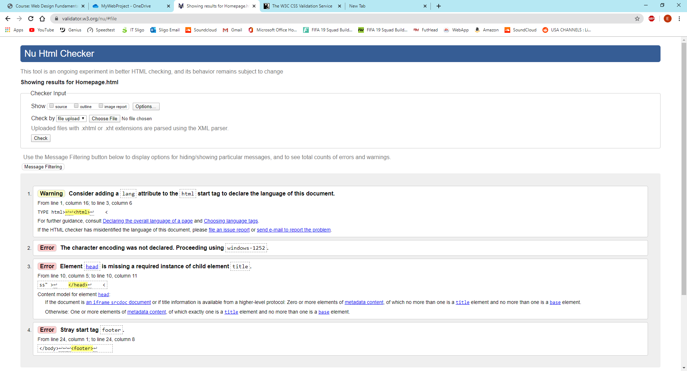

Page 2 – Validation result
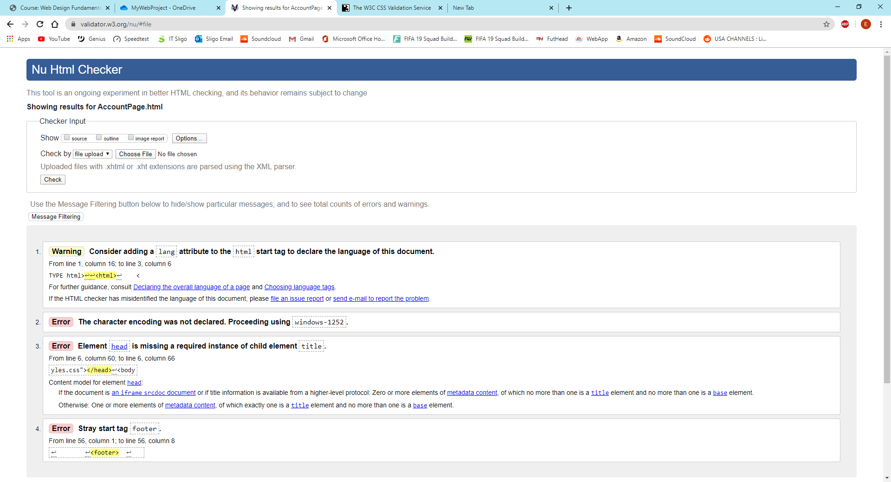

Page 3 – Validation result
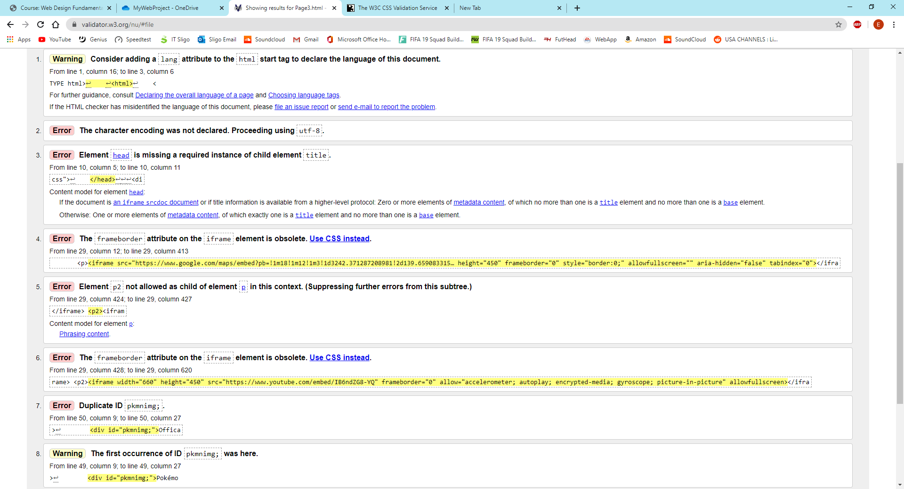
Page 4 Validation results
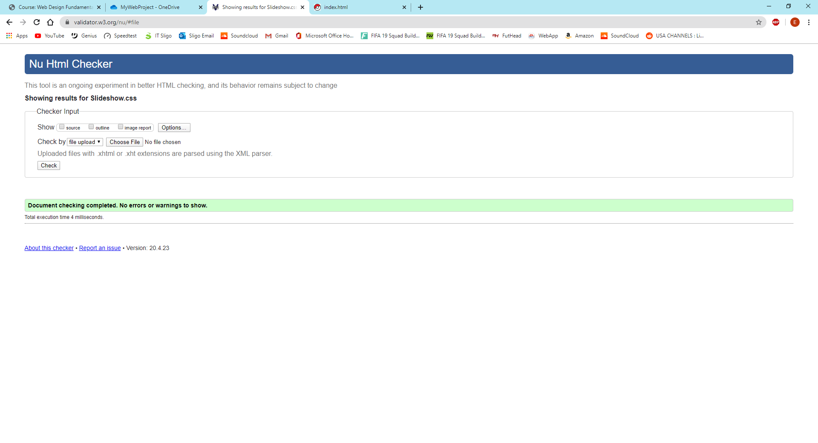

CSS Validation Results
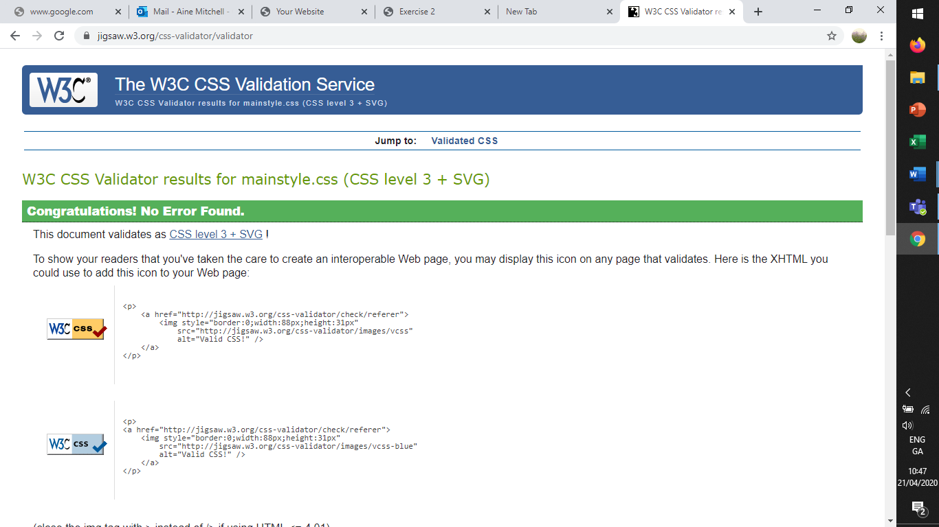
Page1 Css

Page 2 Css
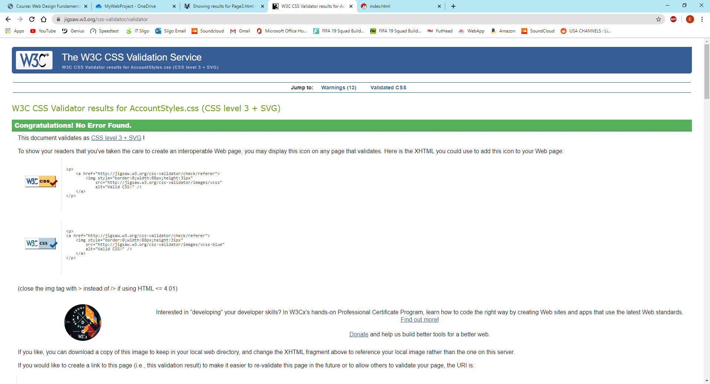

Page 3 css
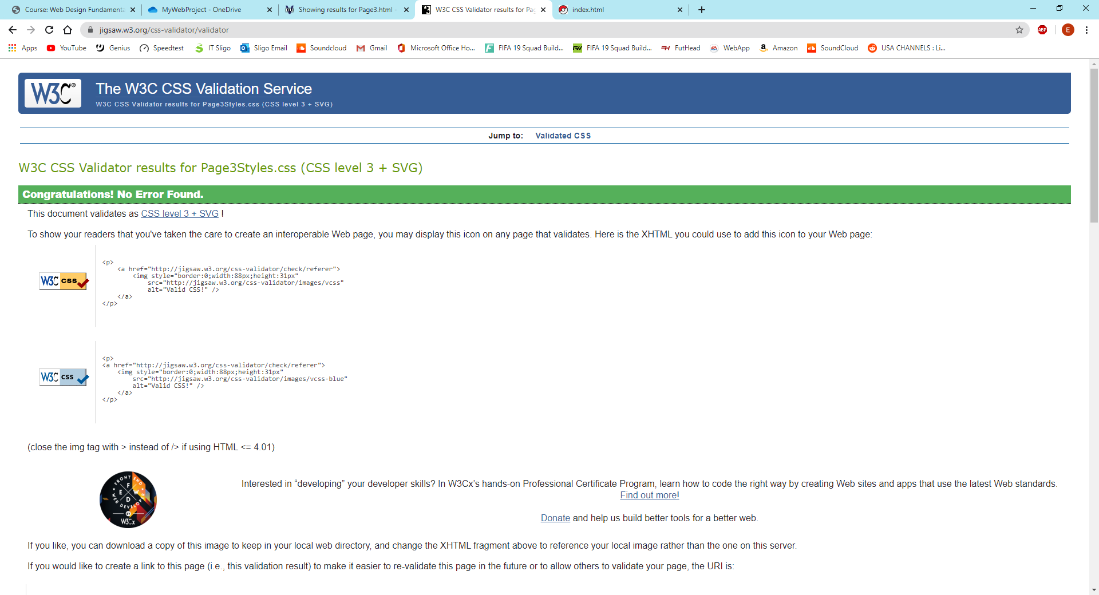

Page 4 Css
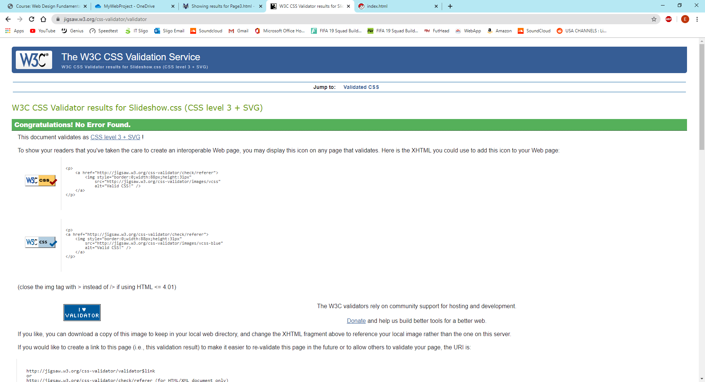

Include Project CheckList – outline where feature are on Website to ensure they are found and marked
You are asked to complete an original website of your own work, the website should contain the features listed below.
Create a website using html5/css that will include the below Project Check List elements: if features are not obvious outline where they are located on the web page below. In order to mark the project the student will present the website and explain the code, declaration of own work submitted.
 ****Must include Report including purpose and intended audience of the website and sources of images and information of each web page and HTML & CSS validation results. Upload entire project to GitHub and upload GitHub url in report
 Minimum of 4 HTML Pages with navigation menu ( outline college project on landing page, do not include any personal or college information in the content of the pages)
 Upload progress and completed website to your GitHub account
 HTML5 standards and recommended page layout structure (header,main,aside,article,footer,etc)
 Include appropriate Meta data – description & appropriate keywords etc to improve pages SEO
 Include font family for web page body
 Appropriate use of External Style Sheet – Recommended CSS
 Appropriate use of Internal & Inline Styling on HTML page (one example of each) used in page 2 for ….
 Home page content aligned to each other and visually attractive
 Include navigation above fold and bottom of web pages- Indicate on navigation the current page
 Include both Class and ID as CSS Selectors used in page 3 to …
 Consistency of design on all pages , use of fonts, colour etc
 Appropriate use of Headings (h1, h2, h3, h4)
 Appropriate use of Colours (test for colour blind users)
 Include an article or section with 2 or 3 columns (by using appropriate css) on the contact page
 Include logo and display in header of page
 Clear, consistent and align content on all pages (reference all sources)
 Include images (with at least one image floated with text alongside) floating image on ….
 Use of background image background image on page …
☐ Include table of data/information on page 2
 Include lists ordered or unordered (different shaped bullet points) on page 1 to display….
 Include a link to a suitable video and google map on page 1 to display…
 Include a contact me form and include red * beside required/mandatory input fields
 Verify data collected on contact form, using get and data attached to URL (Use the method get to display values entered on form will be appended to url and passed to server <form action=" http://year1.ccpdev.me/FormTest.php" method="get">
 Footer information include Copyright© 2020 and navigation
 Internal anchor Links on one of the webpages on page 1 at the …..
 External Link on page 2 to display….
 Any Additional Features included _______ Added …… on page 1 to display ___________

 Results included in report of HTML5 Validation (with majority of issues addressed)
 Results included in report of CSS Validation (with majority of issues addressed)
 Include Favicon on the Title tab
 Guide line on Website appearance, design and Content https://webdesignledger.com/10-signs-of-a-user-focused-design/
 Guidelines on Website overall appearance & design https://webdesignledger.com/20-dos-and-donts-of-effective-web-design/

